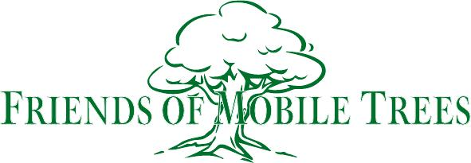

Formed to preserve, promote and celebrate our world class trees

August-September 2023 Progress Update
FOMT’s Airport Boulevard Replanting Project Has Expanded:
First some background. For over a year, Urban Forestry and FOMT planned to replace scrub trees on the public Airport Boulevard medians from I-65 to Azalea Road with a more vibrant species such as Eastern red cedar. FOMT’s members were first to contribute to the purchase of these trees with Urban Forestry contracting to install them. In May, FOMT and the Mobile Tree Commission publicly agreed to split the cost of these replacement trees for the stretch from I-65 to Montlimar (Phase 1). In June, Councilor Joel Daves pledged $5000 from District 5’s Discretionary Fund for the stretch from Montlimar to Azalea Road (Phase 2). In early September, Alabama Power awarded Friends of Mobile Trees a $1,000 grant from its Good Roots program to buy trees for Phase 2.
After this complete funding was earmarked, Urban Forestry told us, for the first time, that the area marked for scrub tree removal is actually much larger, but with fewer trees per mile than previously discussed publicly and privately. Urban Forestry states that its new estimate is to replace between "50 and 60 trees"on four long stretches of city right of way:
1) Airport Boulevard from I-65 to the western city limits.
2) Cottage Hill Road from I-65 to the western city limits.
3) Old Shell Road from I-65 to the western city limits.
4) All of University Boulevard
Urban Forestry states that these marked trees will be taken out “in the next few weeks” and replaced in a few months. Bottom line: this is still the same project, replacing about the same number of scrub trees with a more vibrant species and at about the same cost, but over a larger area with fewer trees per mile. So, we are asking the potential grantors to earmark their pledged funds to the revised area. We will keep you posted as we move forward.
FOMT knows this has been another challenging weather year for Urban Forestry and urban plans can and do change for various valid reasons. Yet, a text or phone call takes only a few seconds. The weather does not mitigate the FOMT Board’s expectation to receive timely communication on behalf of our 847 members. FOMT will continue to patiently collaborate with all of our government leaders, great civil servants and related stake holders towards our stated goals for the trees and those of us in their shade.
Additional Grant Opportunities:

Gulf Coast RC&D Council: Our application was submitted on time and in good order utilizing all available data. A Council decision is expected in October for potential project implementation in Fiscal Year 2024 (starts Oct. 1). We are in touch with Dale Dickens at Alabama Forestry about other potential grants coming later in the year.
“Founding Friends” Campaign: It’s not too late to be a founder and participate with a minimum donation of $100 as one of the many potential local matching funding sources. Mail your tax-deductible contributions to our PO Box below.

Welcome Back Joel!: FOMT is pleased to welcome our new Urban Forestry Extension Agent for Mobile and Baldwin Counties Joel Potter (potterj@auburn.edu). Many of you of know Joel from his time with the City of Mobile's Urban Forestry Dept. More recently, he established the City of Gulf Shores' Urban Forestry Dept. Joel is a long-time supporter of our tree efforts. In fact, FOMT started with a conversation with Joel two years ago standing next to the very large old live oak tree that had to come down in my front yard. Today, that beloved old oak's stump is regenerating nicely despite the record heat, hopefully, a good sign for things to come.

Promotion:
FOMT Website: Thanks to our curator, Dr. Ann Jurgens Pond, we have additional upgrades on mobiletrees.org. Visit the site to see what’s happening and spread the word to others.
Social Media: FOMT is now on Instagram in addition to our Facebook page for non members and our Facebook Group for our 847 members, an increase of 31 new members since July.
Quarterly Meeting: July 16th prior to ArtWalk, the board voted to begin a review for 2024 to identify grant projects in need of FOMT’s assistance. Mark your calendars for the Autumn FOMT quarterly meeting October 13th at 5 PM at Cathedral Square directly across from the Cathedral steps. You are also invited to join us afterwards for ArtWalk to introduce FOMT to our fellow Mobilians.

FOMT P.O. Box 8072, Mobile, Alabama 36689

